**CSE 5331 – DBMS Models and Implementation Techniques**

**Summer 2019**

**Project 2 Phase 1**

**MongoDB Installation & Import of Flat File Document Collections**

**Project Members:**

Goutami Padmanabhan – 1001669338

**Professor:** Dr. Ramez Elmasri

**Mongo DB Folder Directory:**

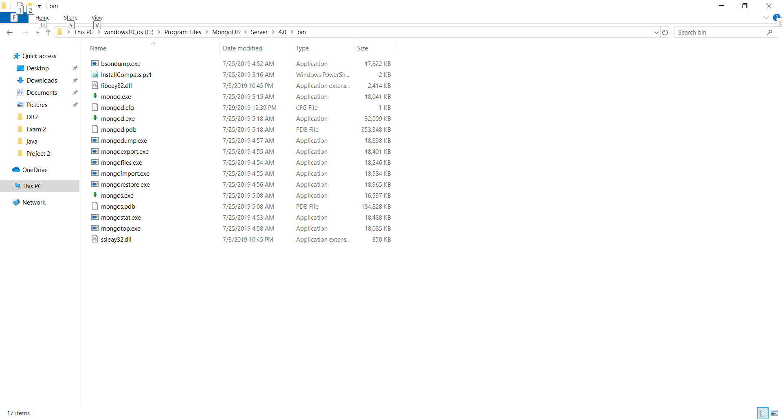

**Mongod Service Execution:**

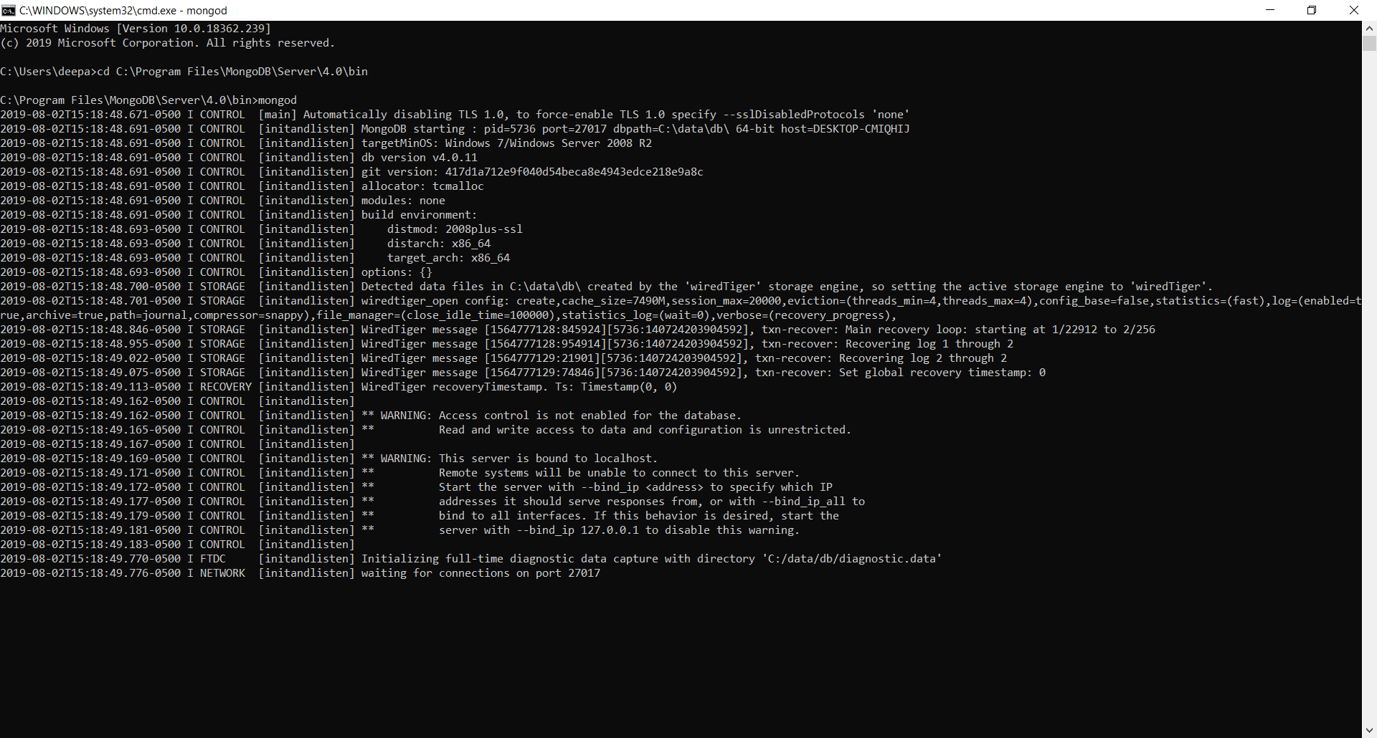

**Import of Flat File Documents (.csv) into MongoDB:**

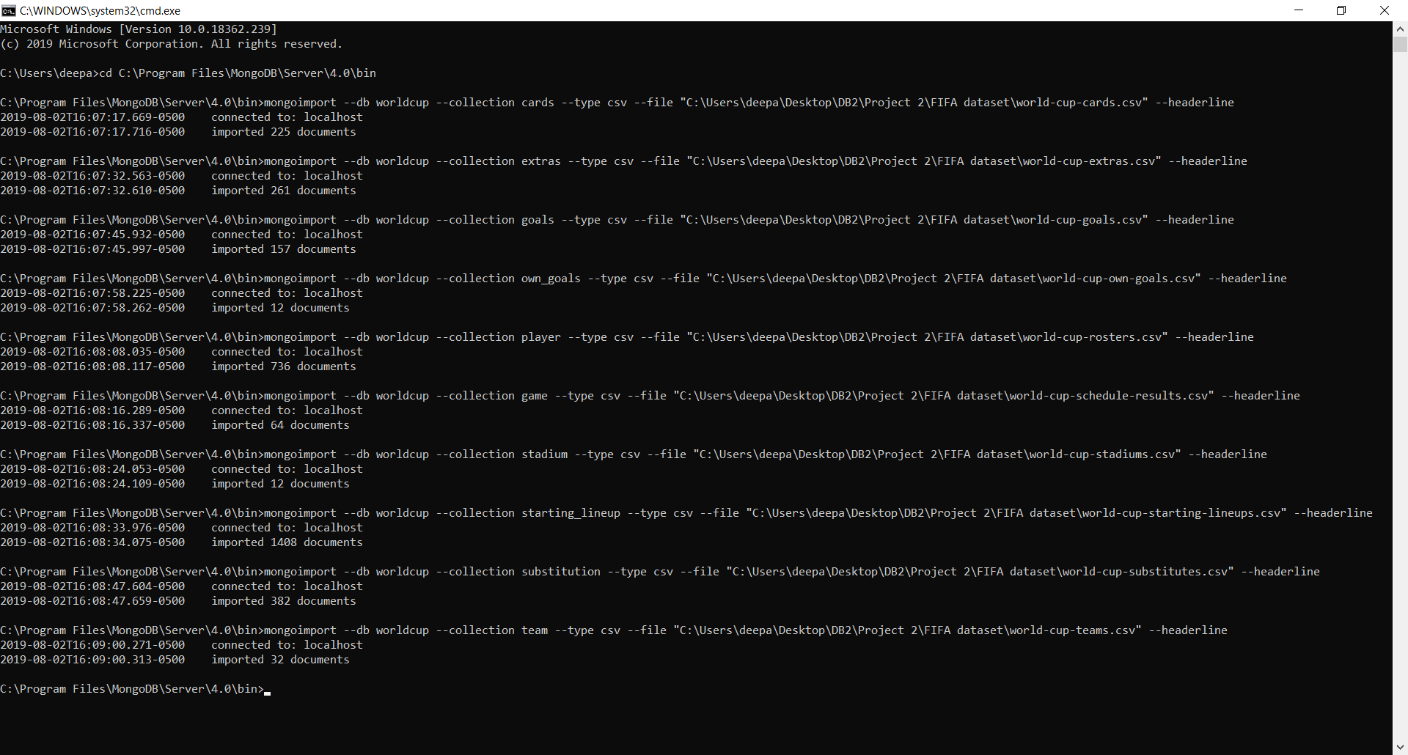

**Execution of Mongo:**

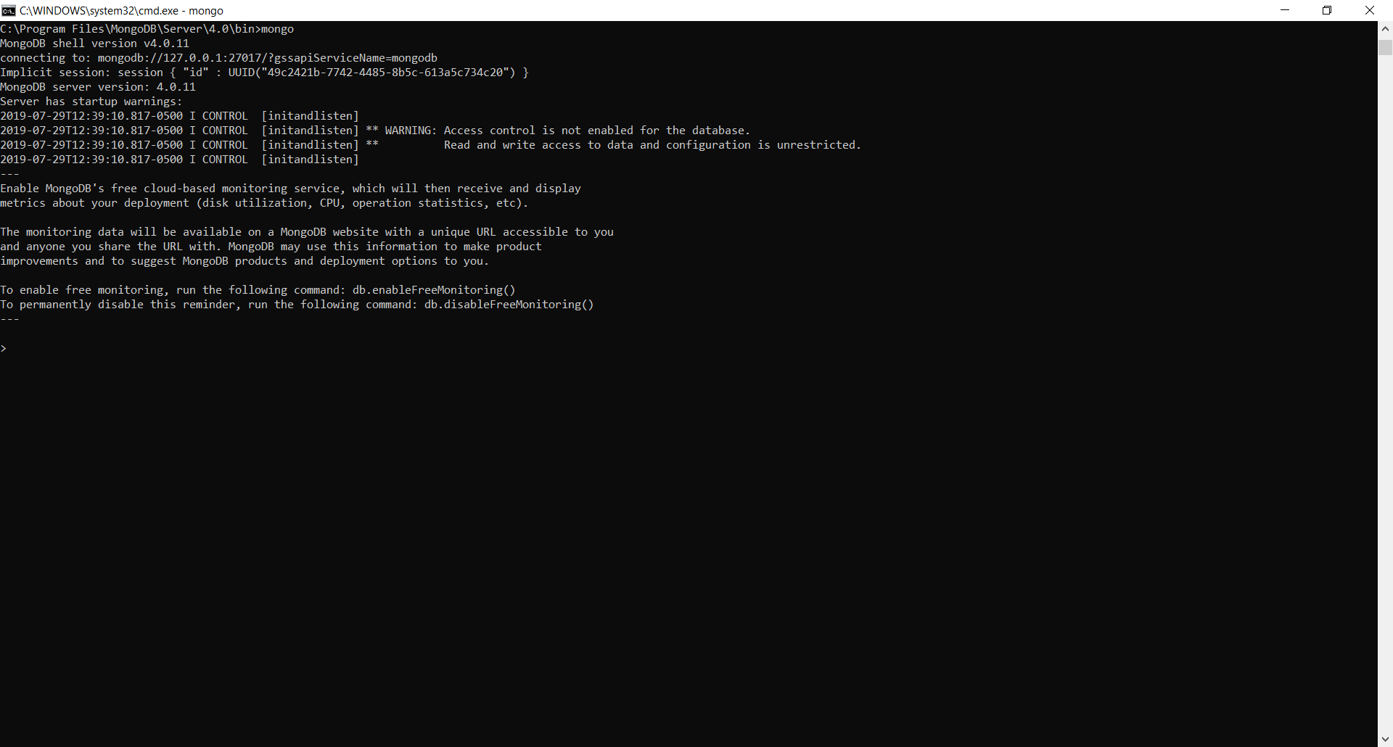

**List of Databases – Using Show dbs command in MongoDB:**

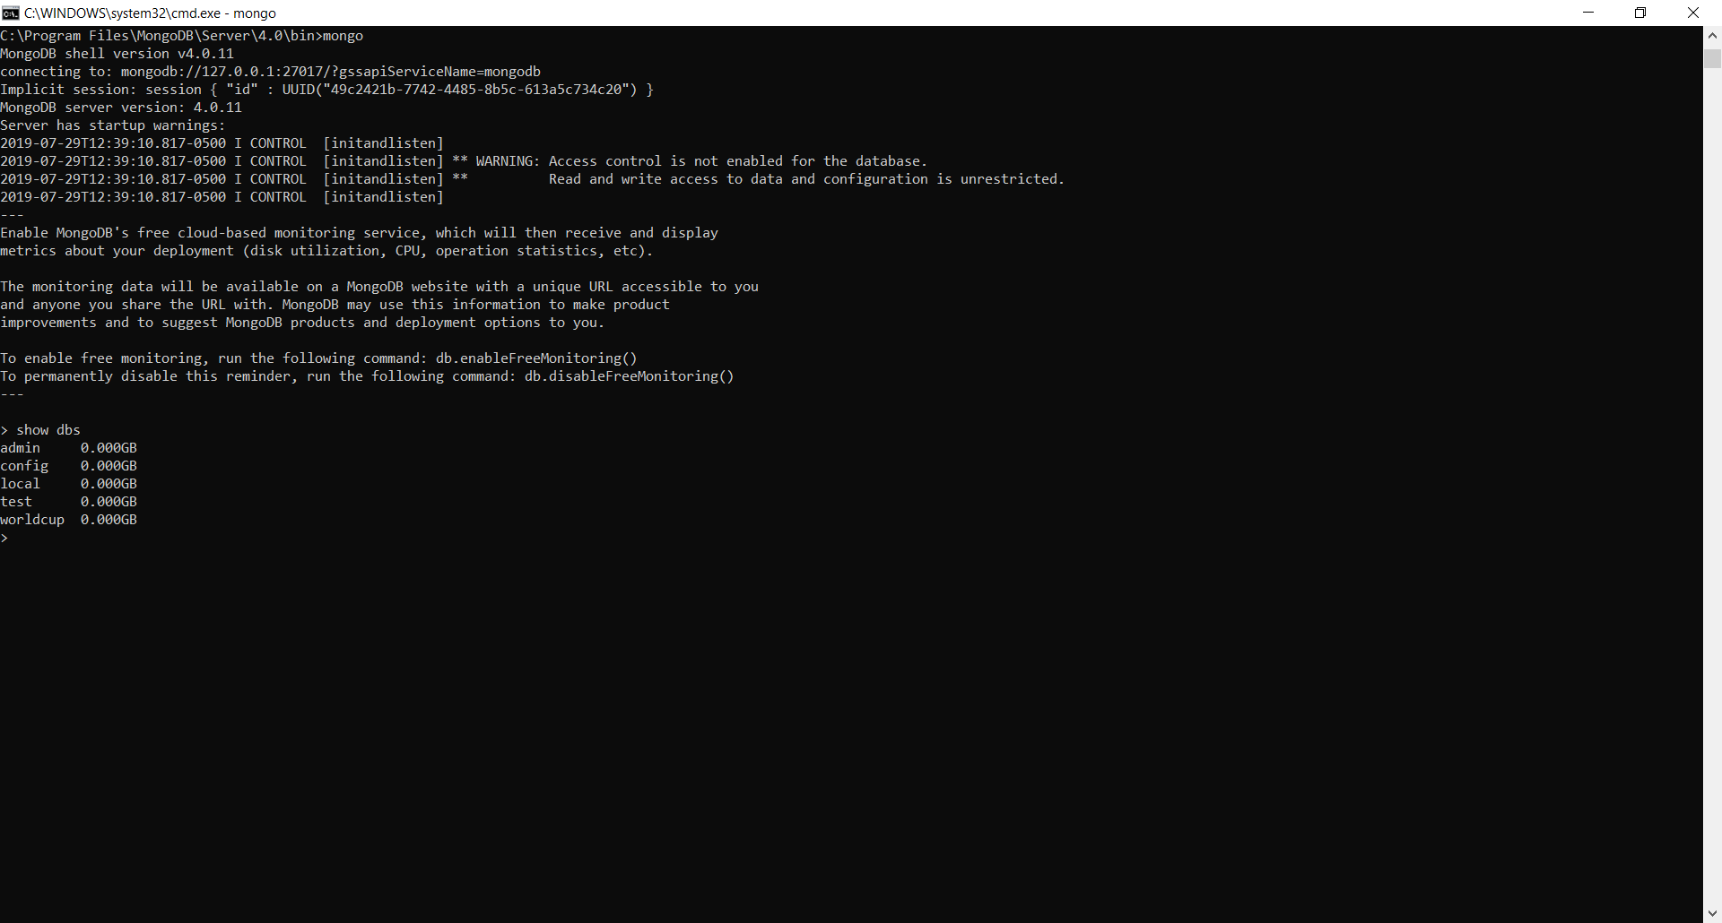

**List of Collections Present in Mongo DB using “Show collections”**

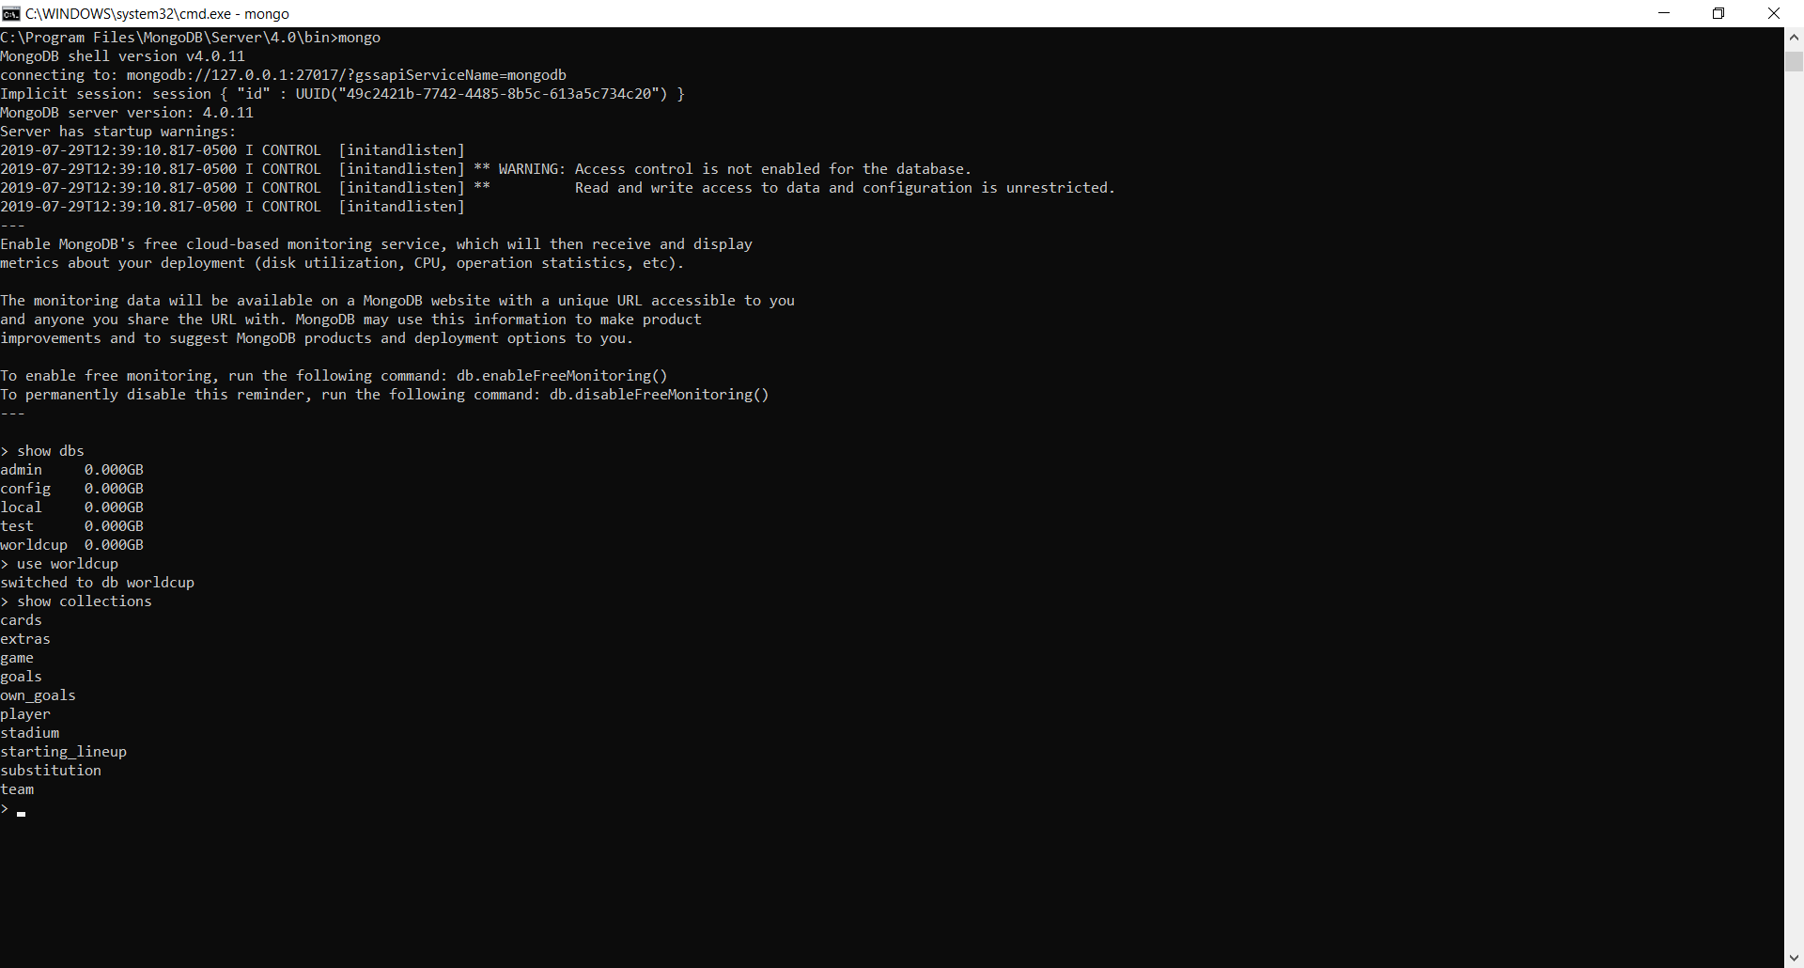

**Viewing List of Documents in Each Collections Created under “worldcup” Database:**

1. **Db.cards.find() and db.cards.count()**

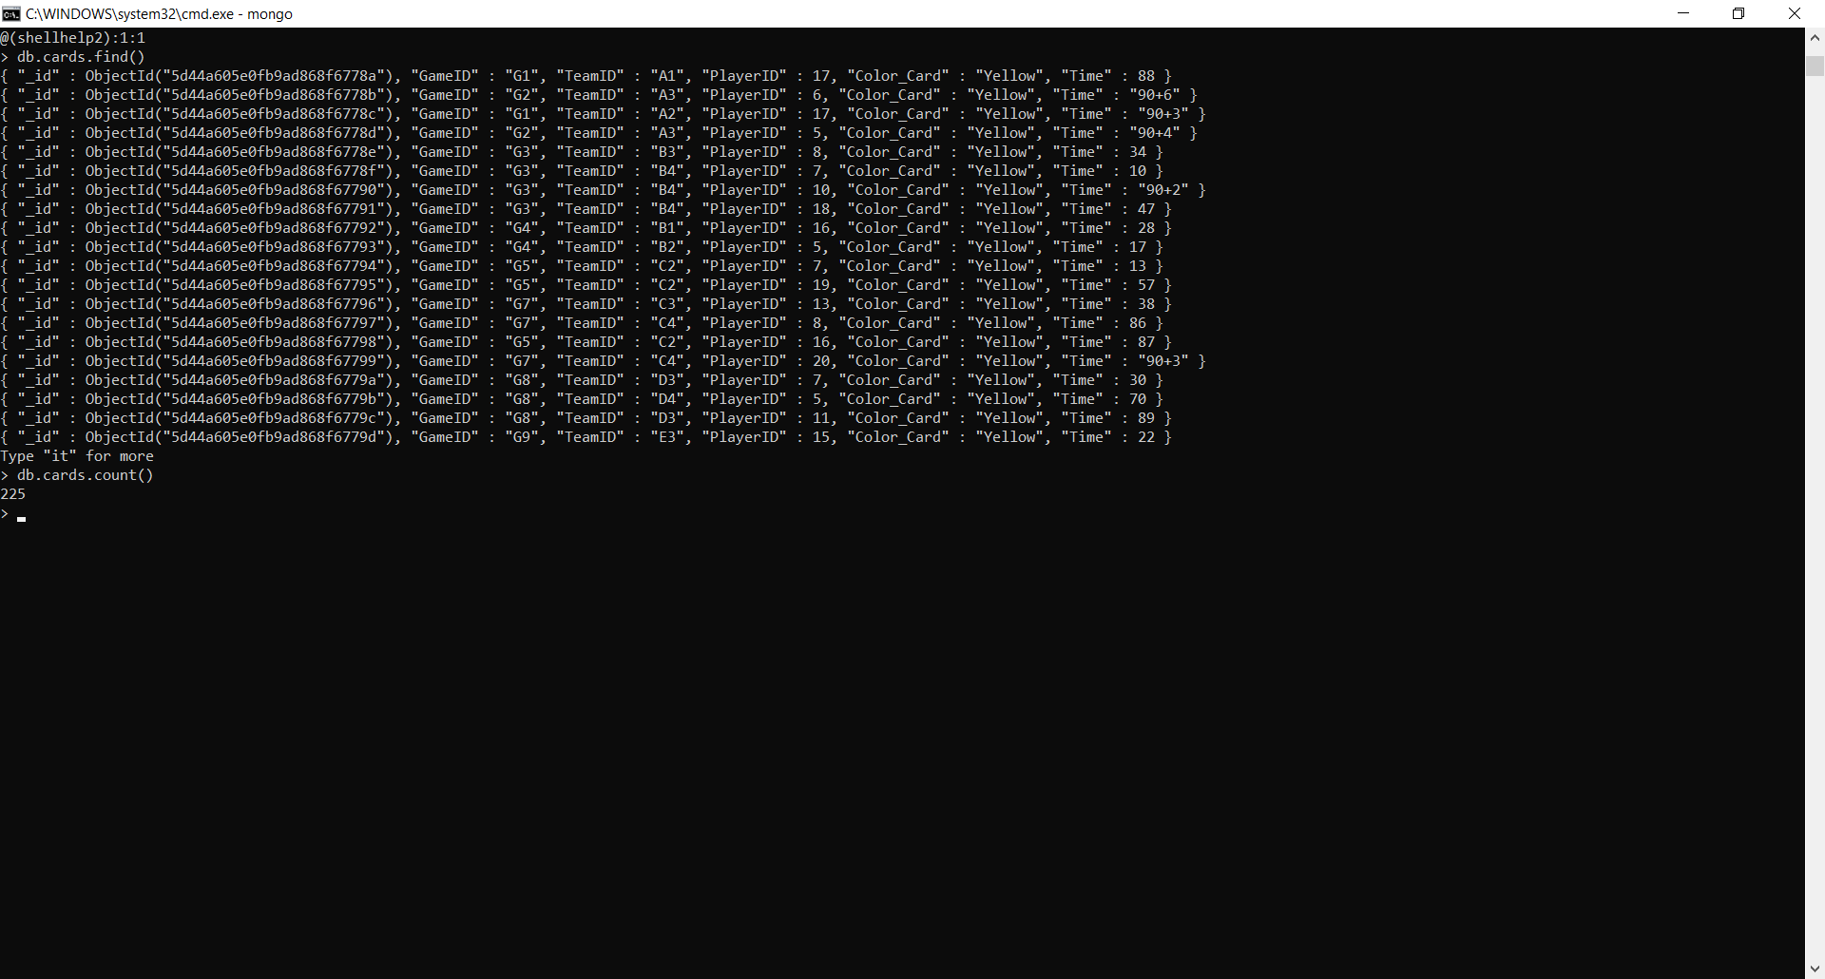

1. **Db.extras.find() and db.extras.count()**

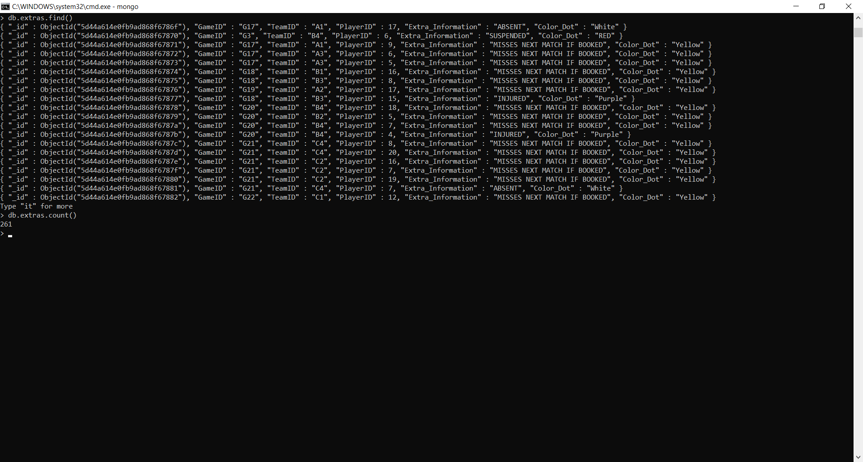

1. **Db.game.find() and db.game.count()**

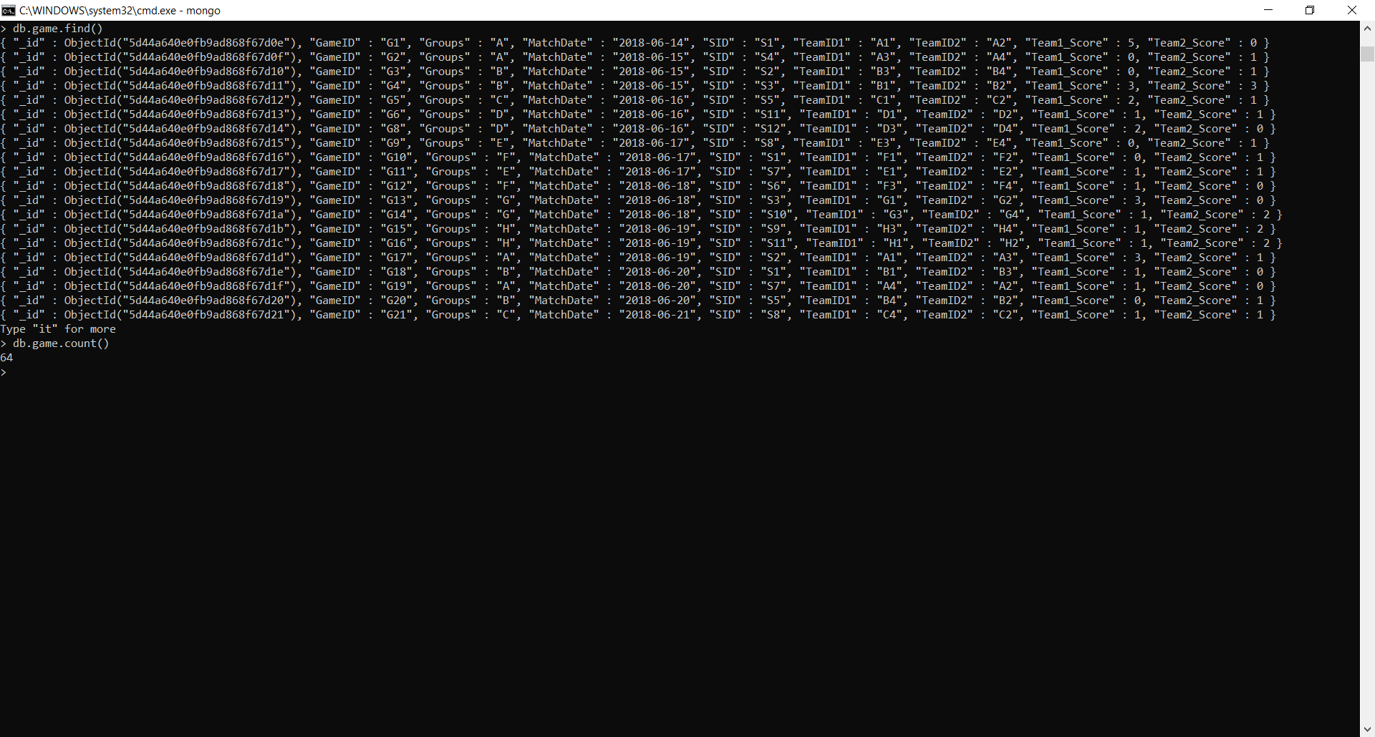

1. **Db.goals.find() and db.goals.count()**

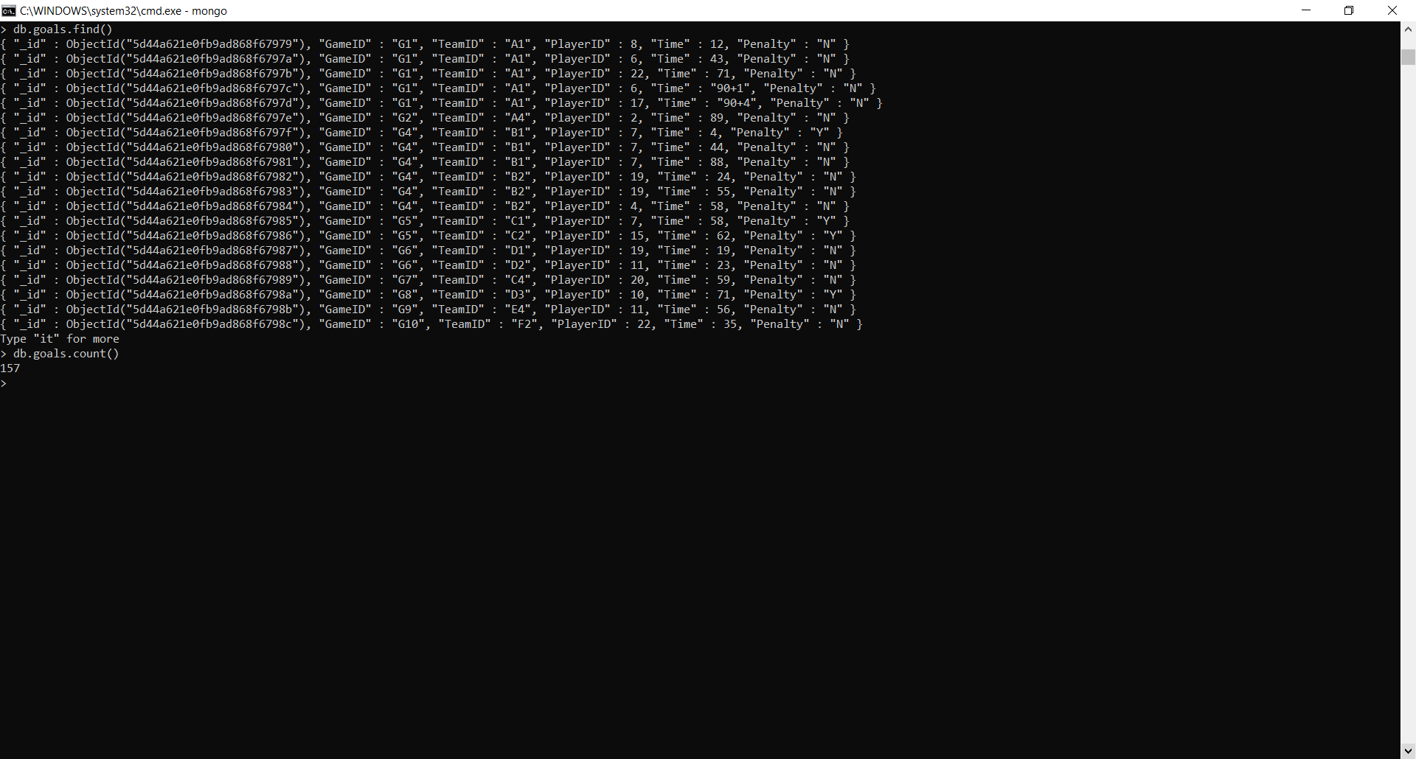

1. **Db.goals.find() and db.goals.count()**

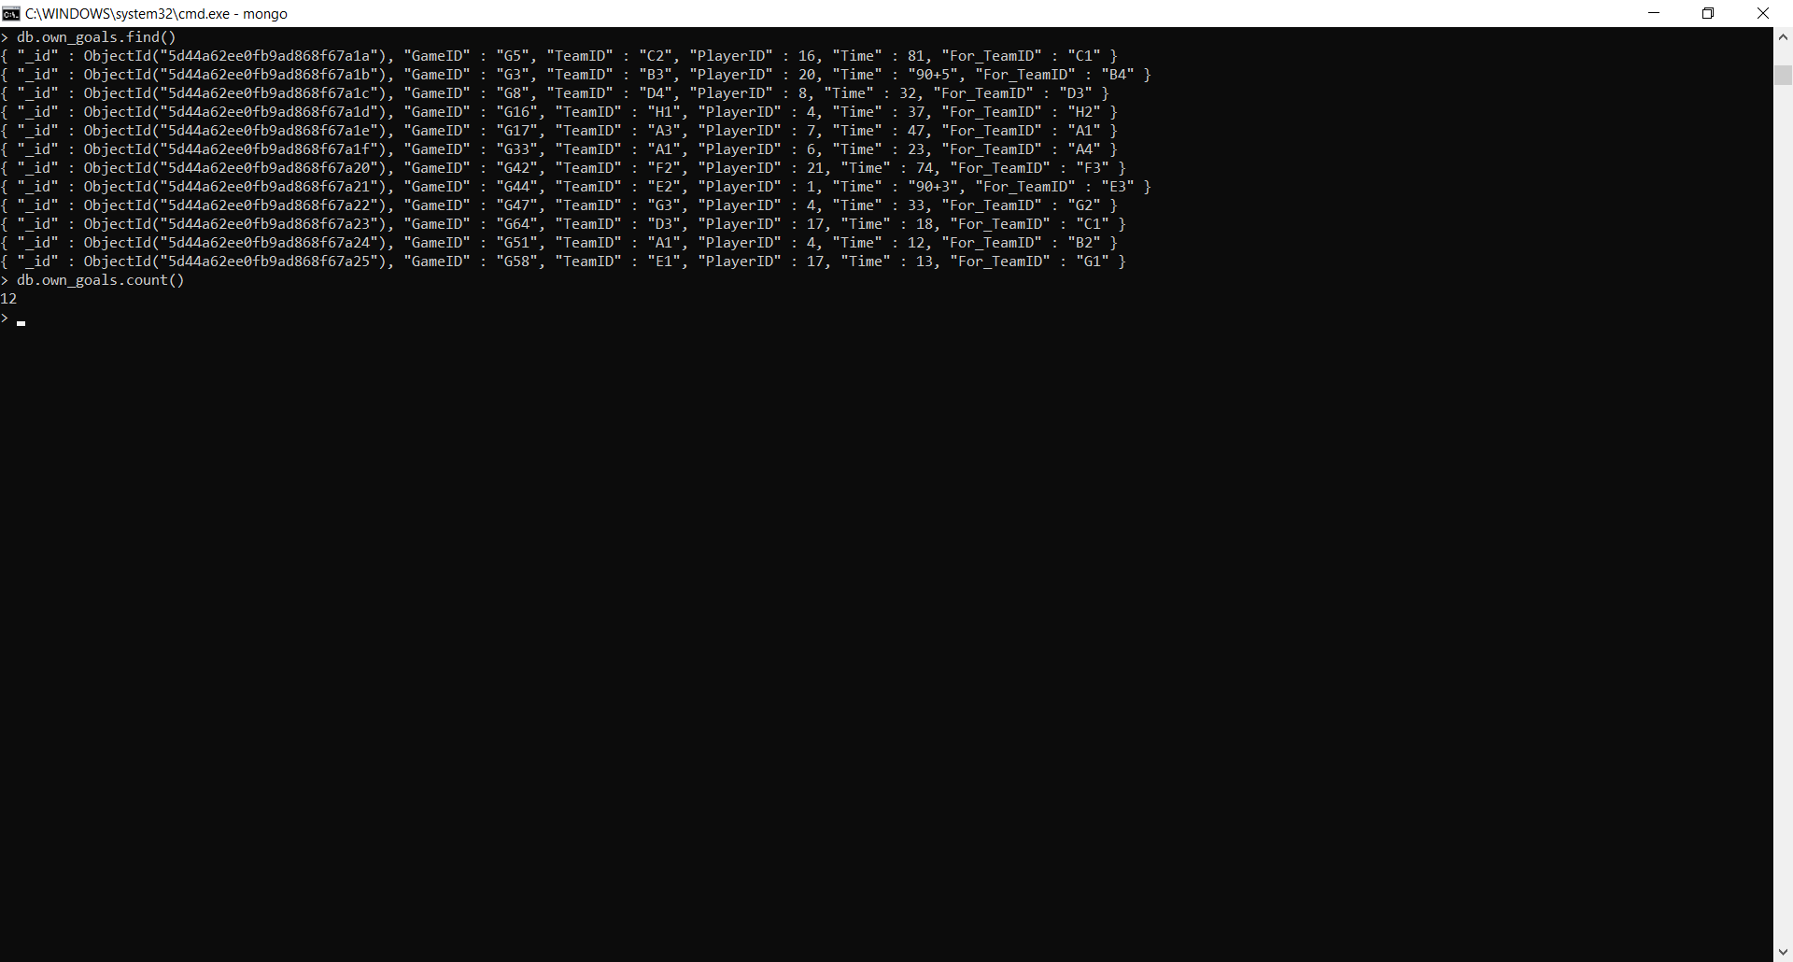

1. **Db.player.find() and db.player.count()**

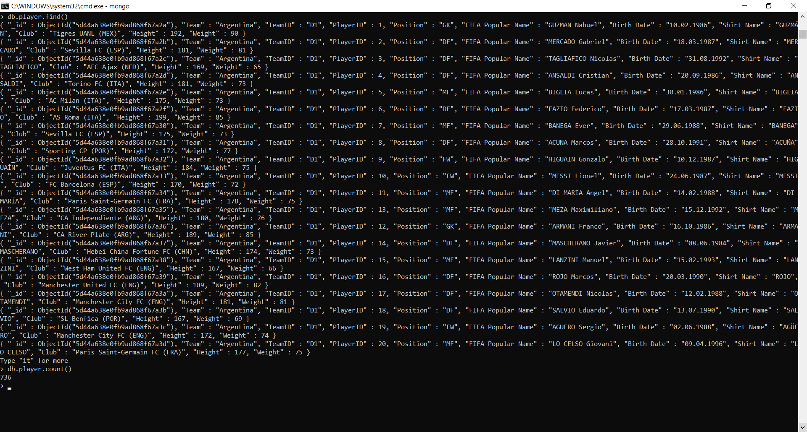

1. **Db.stadium.find() and db.stadium.count()**

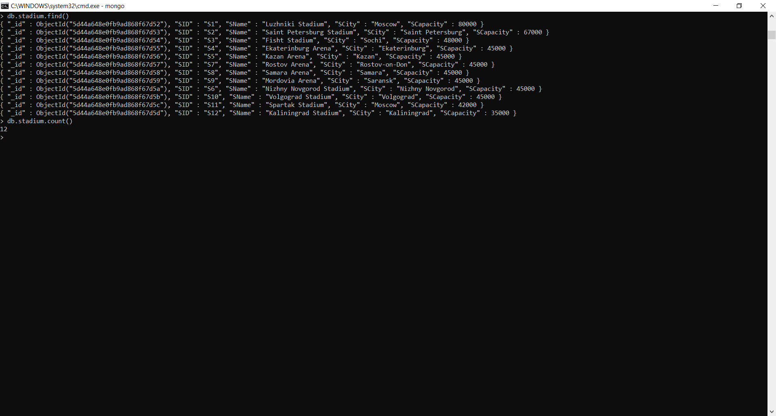

1. **Db.starting_lineup.find() and db.starting_lineup.count()**

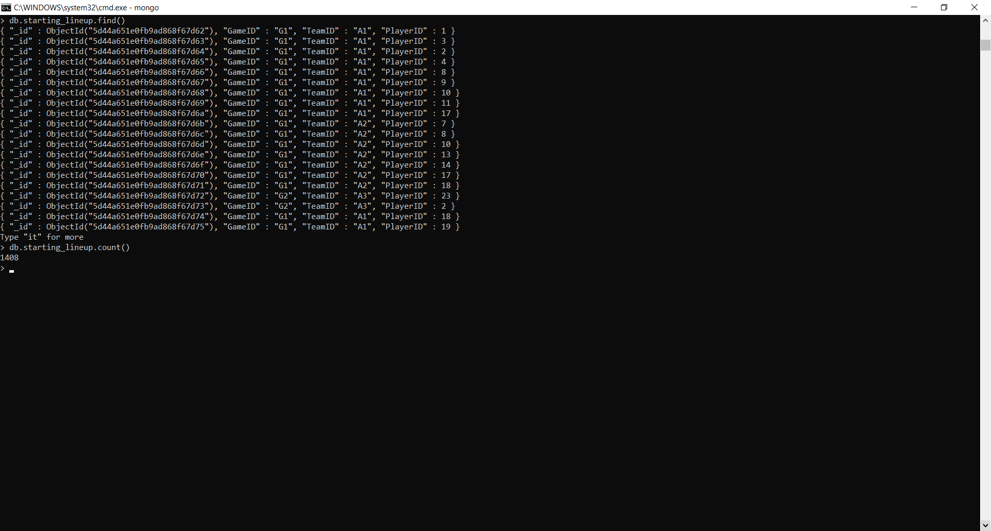

1. **Db.substitution.find() and db.substitution.count()**

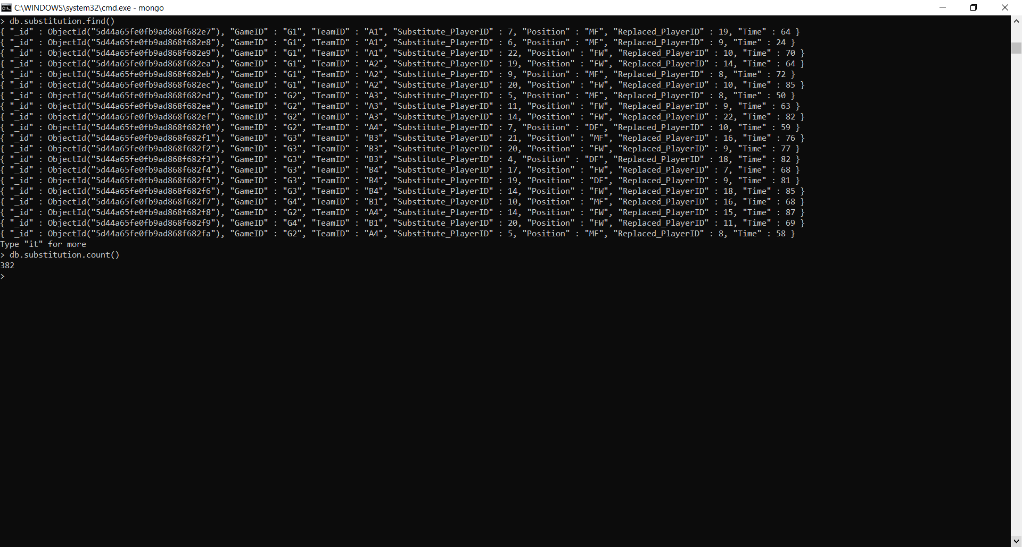

1. **Db.team.find() and db.team.count()**

